**Names**

1. **VICTOR AKOR AMEH**
2. **Godwin Ameh**
3. **Hossana Okah Ameh**
4. **Mark Ondugbe Ameh**
5. **Faith Akogwu**
6. **Testimony Mercy Paul**
7. **Solomon Ojonugwa Akpa**
8. **Agaba Destiny Godwin**

**Details**

**1.**

NAME: Victor Akor Ameh

ADDRESS: No: 1, Zuwai Street, Wuse Zone 6, Abuja

NIN: 95074702350

PHONE NUMBER: 07064959669

EMAIL: akorvikkyy@gmail.com

OCCUPATION: Software Developer

DOB: 30 March, 1995

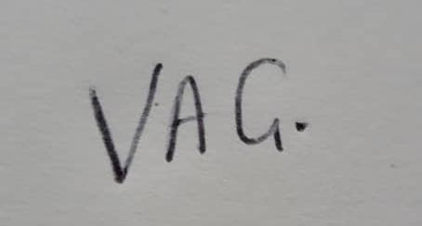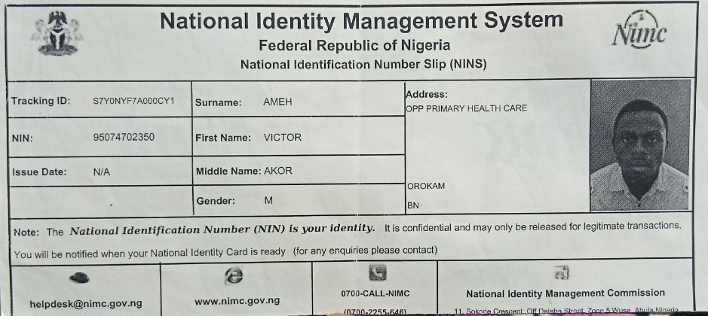

**2.**

NAME: Godwin Ameh

ADDRESS: No: 5 Okpaflo Street Otukpo, Otukpo LGA, Benue State.

NIN: 10744415383

PHONE NUMBER: 07030056755

EMAIL: pastorgodwinameh@gmail.com

OCCUPATION: Teacher

DOB: 29th October 1965

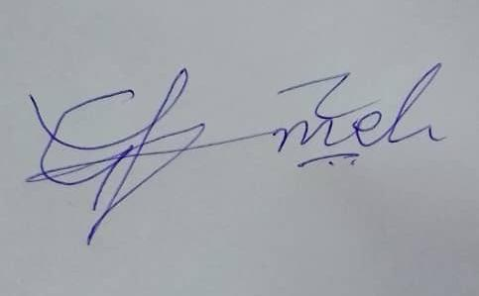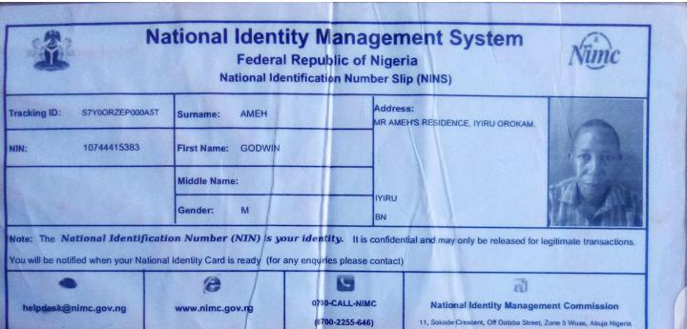

**3.**

NAME: Hossana Okah Ameh

ADDRESS: No5 Okpaflo Street Otukpo, Otukpo LGA, Benue State.

NIN: 52438634755

PHONE NUMBER: 08147393912

EMAIL: nill

OCCUPATION: Trader

DOB: 10th March 1979

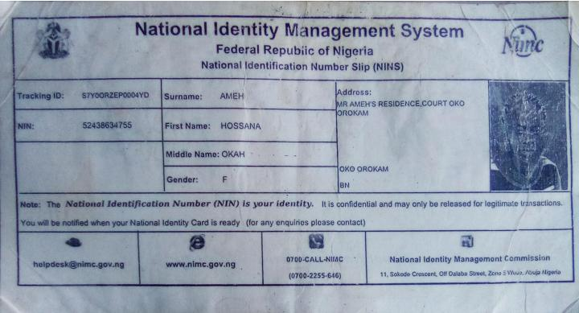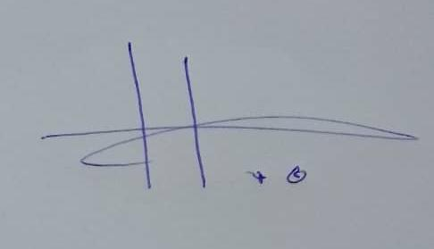



NAME: Mark Ondugbe Ameh

ADDRESS: No:20 Mari-joe Street, Angwan Soja, Masaka, Karu Local Government Area, Nasarawa State.

NIN: 46210392314

PHONE NUMBER: 09039026560

EMAIL: gmk.mark101@gmail.com

OCCUPATION: Self Employed

DOB: 30, June, 1998.

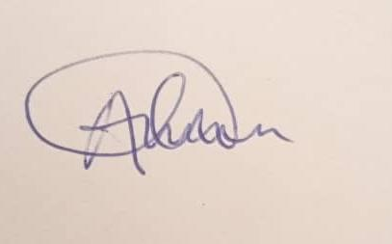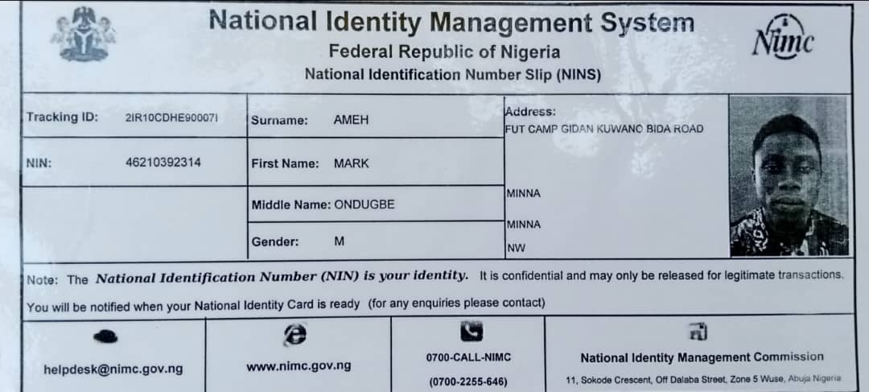

**5.**

NAME: Faith Akogwu

ADDRESS: No: 10, Ipole Ejema, Orokam, Ogbdibo LGA, Benue State.

NIN: 92763256608

PHONE NUMBER: 08144079201

EMAIL: akogwufaith@gmail.com

OCCUPATION: Student

DOB: 15, August, 1999.

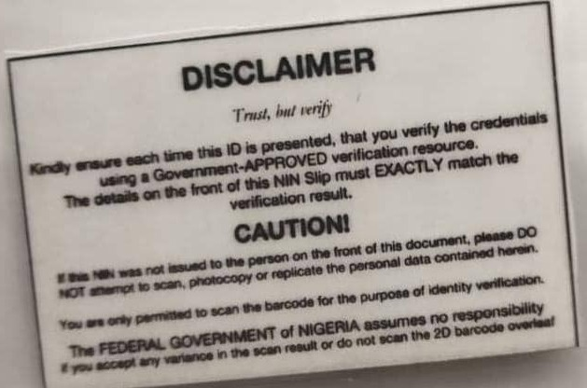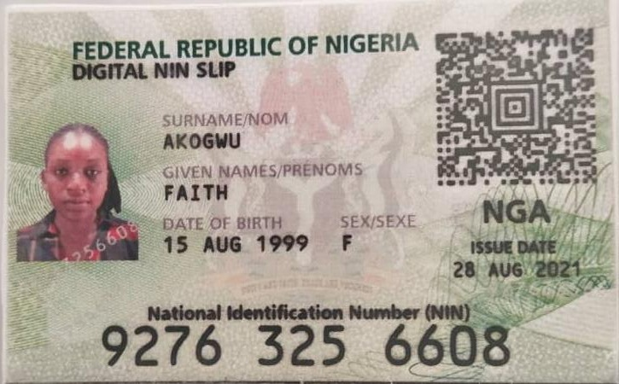

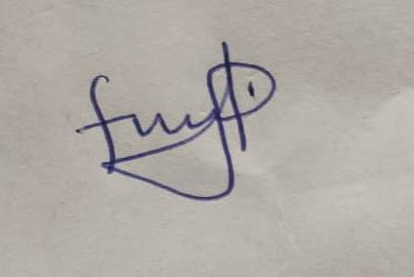

**6.**

NAME: Testimony Mercy Paul

ADDRESS: No: 54 Ayishi ETTE Igbo-eze north local government Enugu state

NIN: 29836583133

PHONE NUMBER: 09036071808

EMAIL: paulmercy517@gmail.com

OCCUPATION: Entrepreneur

DOB: 08 April, 1995

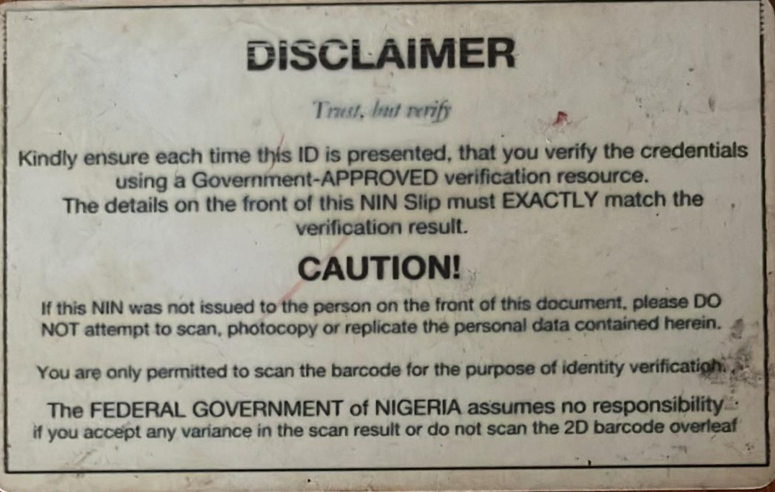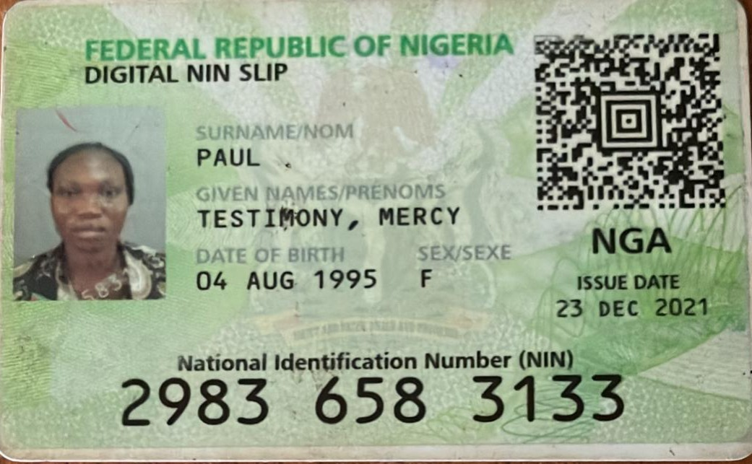

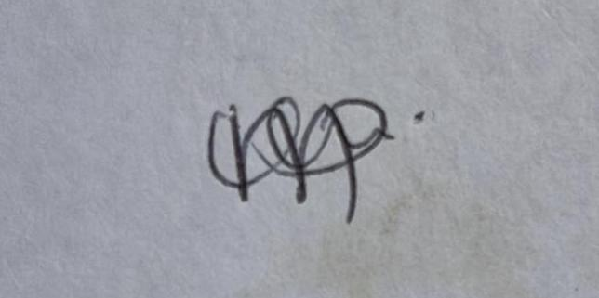



NAME: Akpa Solomon Ojonugwa

ADDRESS: No2, Adetoun Adesoye close Egan Igando. Alimosho local government, Lagos

NIN: 27493840299

PHONE NUMBER: 08102809730

EMAIL: solomonakpas@gmail.com

OCCUPATION: Facility manager

DOB: 6th July 1994

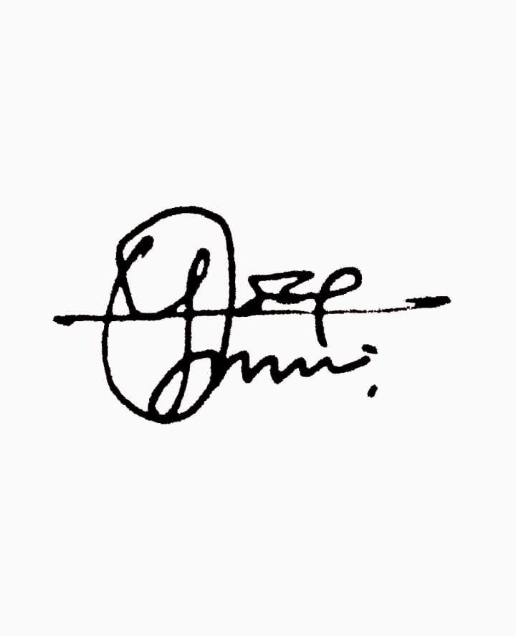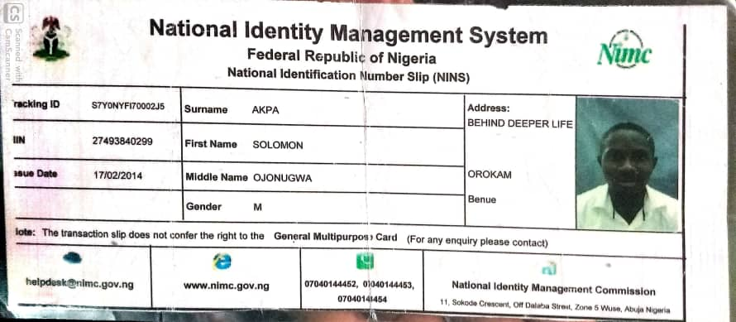



NAME: Agaba Destiny Godwin

ADDRESS: No: 7 Future, Orokam, Ogbadibo local government

NIN: 33121518657

PHONE NUMBER: 09162087460

EMAIL: Agabadestinyadoche@gmail.com

OCCUPATION: Student

DOB: 4 November 2003

